- EROTC QLQ-C30 item list (Scoring Manual | EORTC – Quality of Life)
Figure 1
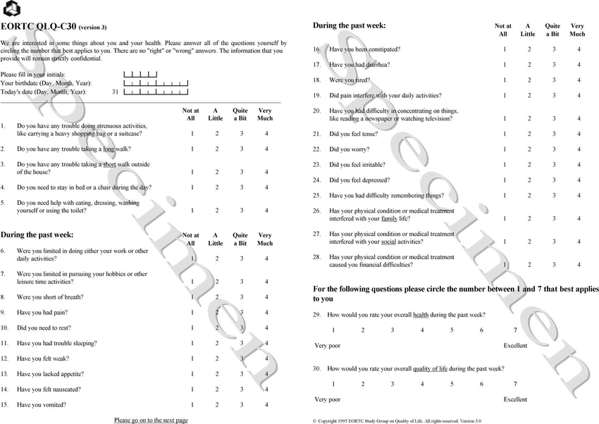
Figure 2
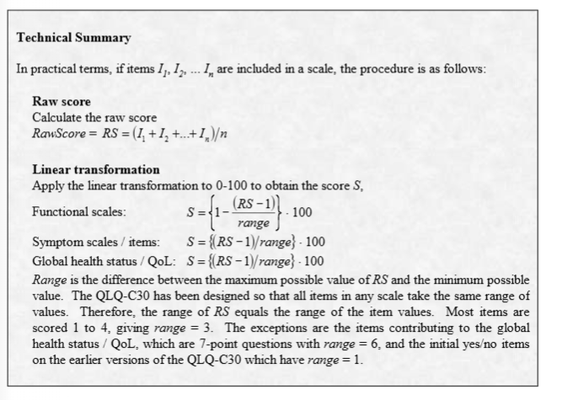
Figure 3
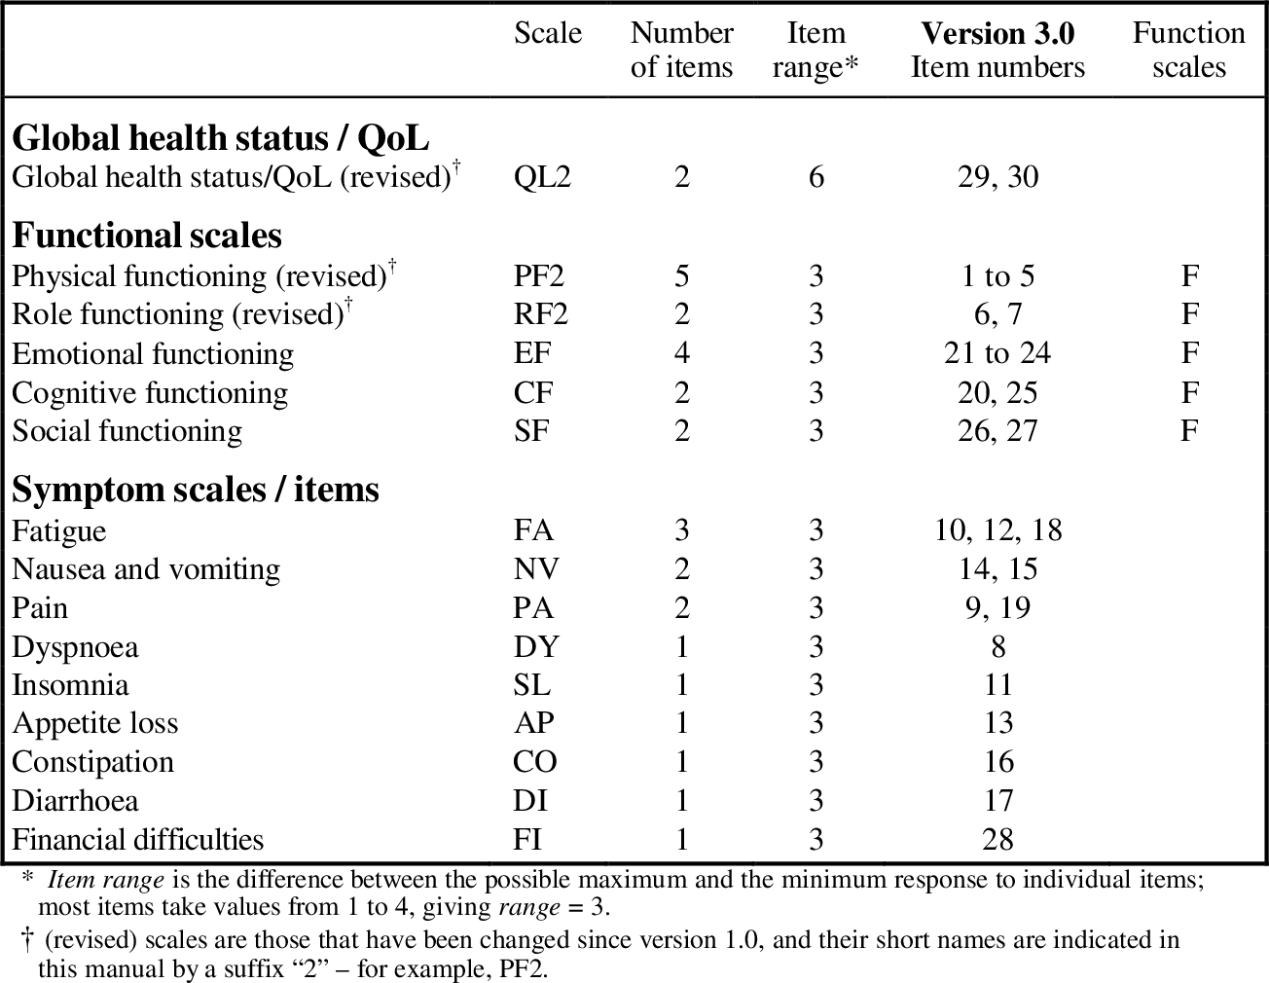
Figure 4
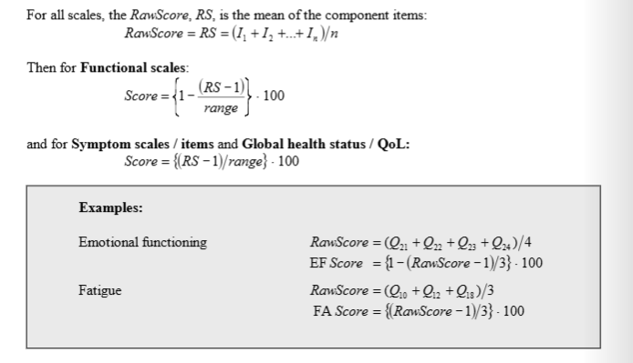
Week 1 Plan
Data Summary
- How many patients (USUBJID) by study, number and proportion
- `How many subjects do not have EROTC-QLQ C30 data by study (DV = -999 at all time points), number and proportion
- How many data points are missing in each study (DV = -999)
- How many data points are missing by question (30 questions).
Datasets
Exclude TIME = -999 and DV = -999
- Generate GHS dataset, Select question 29 and question 30, Only include the timepoints with both 29 and 30 are not missing. (First calculate how many subjects/data points are omitted due to this). each subject at each timepoint, have one DV2 = [(RS-1)/6]*100, RS = average score of item 29 and 30. After generating this dataset, summarize the number of subjects by study. Keep all covariates. Name the dataset as Breast_PRO_GHS_Date.csv (include all columns from merged dataset, but have DV2). FLAG = QL2, delete old DV and FLAG.

- Generate 9 subset dataset, for each symptom in figure 3 table.
Steps: Only include the timepoints where all related questions are not missing. (First calculate how many subjects/data points are omitted due to this). Add a variable FLAGS for the symptom, FLAGS is the Scale in the Figure 3. Calculation methods similar to above, DV2 = = [(RS-1)/3]*100. RS is average of the question number according to table in figure 3. Name the dataset as Breast_PRO_Fatigue_Date.csv. FLAG = scale
Question 1: Which symptom/QOL deterioration is most prognostic of disease progression? And which clinical definition of deterioration can best capture disease progression?
Goal: generated different definitions TTD (time to deterioration)
For each dataset (total 10 datasets, GHS plus 9 symptoms), summarize for each dataset, each subject, find the following timepoints and generate new variables. (https://link.springer.com/article/10.1007/s11136-013-0583-6)
Variable TTFD10: Compared to baseline, the time of first DV that is 10 points lower than baseline (GHS dataset) or 10 points higher than baseline (symptom datasets).
Variable TTFD5: Compared to baseline, the time of first DV that is 5 points lower than baseline (GHS dataset) or 5 points higher than baseline (symptom datasets).
Variable TTFD10Best: Compared to best previous score, the time of first DV that is 10 points lower than baseline (GHS dataset) or 10 points higher than baseline (symptom datasets).
Variable TTFD5Best: Compared to best previous score, the time of first DV that is 5 points lower than baseline (GHS dataset) or 5 points higher than baseline (symptom datasets).
Variable TTFD10P: Compared to previous score, the time of first DV that is 10 points lower than baseline (GHS dataset) or 10 points higher than baseline (symptom datasets).
Variable TTFD5P: Compared to previous score, the time of first DV that is 5 points lower than baseline (GHS dataset) or 5 points higher than baseline (symptom datasets).
